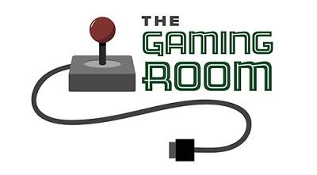

GamingRoomApp

CS 230 Project Software Design Document
Version 1.2

Table of Contents

1.CS 230 Project Software Design Template 1
Table of Contents 2
Document Revision History 2
Executive Summary 3
Requirements 3
Design Constraints 3
System Architecture View 3
Domain Model 3
Evaluation 4
Recommendations 5
2.Operating Platform: <Recommend an appropriate operating platform that will allow The Gaming Room to expand Draw It or Lose It to other computing environments.> 5
3.Operating Systems Architectures: <Describe the details of the chosen operating platform architectures.> 5
4.Storage Management: <Identify an appropriate storage management system to be used with the recommended operating platform.> 5
5.Memory Management: <Explain how the recommended operating platform uses memory management techniques for the Draw It or Lose It software.> 5
6.Distributed Systems and Networks: <Knowing that the client would like Draw It or Lose It to communicate between various platforms, explain how this may be accomplished with distributed software and the network that connects the devices. Consider the dependencies between the components within the distributed systems and networks (connectivity, outages, and so on).> 5
7.Security: <Security is a must-have for the client. Explain how to protect user information on and between various platforms. Consider the user protection and security capabilities of the recommended operating platform.> 5

Document Revision History

Version | Date | Author | Comments
1.0  1.1  1.2 | 01/13/23  02/04/23  02/19/23 | Christian Tavares  Christian Tavares  Christian Tavares | Initial Version  “Evaluation” filled out  “Recommendations” filled out

Instructions
Fill in all bracketed information on page one (the cover page), in the Document Revision History table, and below each header. Under each header, remove the bracketed prompt and write your own paragraph response covering the indicated information.

Executive Summary

The client, Chat Away, has a request to outsource us for programming a mobile app for their successful social media website. The goal should be to market this app to as large a customer base as we can to increase revenue. Chat away aims to keep the project within a specified budget.

Requirements

-The product must be a mobile application for their social media website.
-The product must be marketed to a broad customer base.
-The product has a predetermined budget that we must keep considered.

Design Constraints

Addressing the 1st requirement is as simple as the requirement itself. The product will be a mobile application available from the smartphone's designated app store. So our primary constraint is to make this product a mobile app, clear and simple.
To address requirement 2, we will need to design this mobile app to be on several operating systems for smart phones. We need to think bigger and reach as many audiences as we can for smartphones.
The app will be outsourced to us under the condition that we adhere to a budget. Further details will be expounded on in time.

Domain Model

Using the UML Diagram below, we can see that the GameService class is where everything under the hood will begin. GameService will create a set number of games, which will create a set number of teams, which will create a set number if players. Game, Team and Player will all inherit from the Entity class through polymorphism.

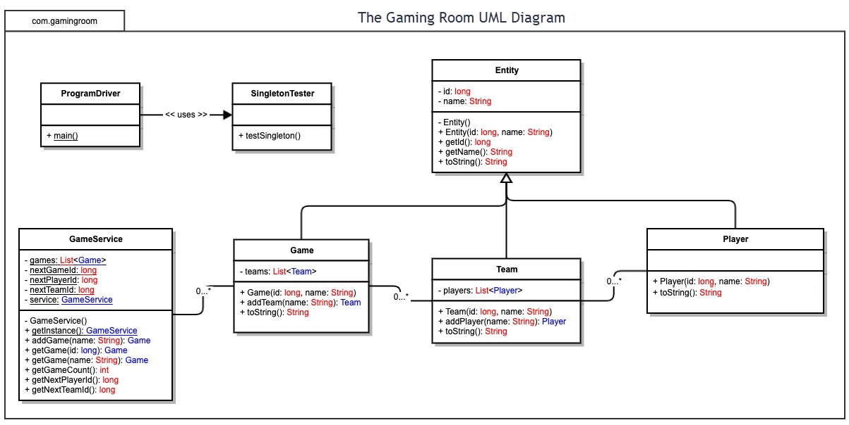

Evaluation

Using your experience to evaluate the characteristics, advantages, and weaknesses of each operating platform (Linux, Mac, and Windows) as well as mobile devices, consider the requirements outlined below and articulate your findings for each. As you complete the table, keep in mind your client’s requirements and look at the situation holistically, as it all has to work together.

In each cell, remove the bracketed prompt and write your own paragraph response covering the indicated information.

Development Requirements | Mac | Linux | Windows | Mobile Devices
Server Side | Mac is one of the most expensive options on this list for server hosting. However, it is more secure than windows and fairly straight forward. | Linux is a free, open source OS with a server hosting option that is secure and efficient. It can be difficult to use for newcomers. | An easy to use, default option for server hosting. Less secure than other options due to how widely used Windows is. | Server hosting is possible, but uncommon on mobile devices. The hardware is limiting versus a desktop as well.
Client Side | In my experience, Mac is almost always a more expensive option in terms of obtaining the OS and a PC for it. It's compatibility only matters among other Mac products. It will work well, though. | Linux is free and open source to modify. There should be zero costs on a client level to obtain the OS. Potential licensing costs for distributing a linux based desktop app, however. | The user would need to purchase a copy of windows to be able to have access to this app on this OS. They may also need to purchase the app from where it's licensed if this route is chosen. | The client simply needs to own a phone (which almost everyone does in this day and age) as well as downloading whichever app is needed to access the game (or browser).
Development Tools | Something like Dreamweaver might be a good pick to create the website code as a tool for the job. Beyond this, a server hosting software would be needed. | Ubuntu is a free server hosting platform for linux that should do the job just fine. Other tools would include an IDE to write the code that is run for the website. | You would need to purchase a license for the more reputable tools like Windows Server. There are free IDE options for coding the game. | Mobile web server is open source and available to host servers right from your smartphone. The actual coding bit would probably have to be done on a PC.

Recommendations

Analyze the characteristics of and techniques specific to various systems architectures and make a recommendation to The Gaming Room. Specifically, address the following:

- Operating Platform: My recommendation goes to a Linux-based platform. It seems the most well fitting for the job. Below, we will go over the reasons why.

- Operating Systems Architectures: Linux is a free and open source OS that will allow you to do all of the things required. It is secure, since malware is typically designed for Windows users (as this is the most used OS), plus it is a very stable and effective OS that can take some time to familiarize with if you are strictly a windows user. However, once you familiarize with Linux, you will be good to go. And once again, it is open source and customizable.

- Storage Management: Since the server will be accessed by many clients that are all going to be playing games of their own, I would argue against just having a host computer with internal storage for the project. This sort of project would benefit from a server machine to host the website and store the hard data that is needed. It should also enhance security, however there are price considerations to be made.

- Memory Management: To optimize information to be at it's fastest, RAM should be utilized over hard memory, especially with image files. The server will hold all of the image data that is needed in hard memory, then whatever files are needed for the game (generated for each round, presumably) will be accessed and sent to the client to save to RAM as the application is running. I don't see the game being too intensive to not be able to run several instances of the game from it's own RAM, but there is not enough information to make a judgment call if this will work with one server machine or not.

- Distributed Systems and Networks: Because this application is web-based, connectivity should be relatively simple. The previously mentioned server will bench all of the heavy lifting by hosting the website that the client connects to. All platforms in the equation have support for a web browser, so this route would be the simplest. Otherwise, assuming there are distributed applications involved then the client's app would act as an interpreter to interact with the hosted server. There's an extra step in the latter form, but would provide a more customized experience. The main thing to take consideration of are hardware limitations, so it should be as optimized as humanly possible.

- Security: Since the server is Linux-based, the security will be quite solid compared to windows since the majority of malware and viruses are designed for windows users specifically. Furthermore we have the option to implement further security by using a second system to act solely as a firewall for the server since Linux allows for this functionality. The system can be very low-spec as and work perfectly fine for the job. For the cherry on top, we will implement a user login system where clients create an account username and password to login from. This not only increases security but can allow us to implement other features to track like the amount of played games or playtime on a user profile to better the user experience.

